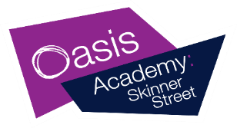
Dear Parent/Carer(s),
Under the new General Data Protection Regulation (GDPR) how we legally process your child’s data has changed. We must seek your consent to use your child’s name or image for specific types of promotional activities we may undertake on behalf of the academy or Oasis Community Learning.
If we do not receive your consent for the items listed below then we will no longer use their personal data for these types of activities.
If you wish to withdraw your consent at any time, please contact the School Office.
Use of information and image (including photographs and video recordings)
I give my consent for the use of my personal data for the following: | Yes | No
Name to be used on the academy’s website, printed publications and local media
Image/video to be used in the academy (for example, in wall-mounted displays)
Image to be used in printed the academy’s publications (for example, the academy prospectus)
Image/video to be used on the academy’s website
Image/video to be used on the academy’s social media channels
Image/video to be used in local media to represent positive stories about the academy
Image to be used in Oasis Community Learning’s printed publications (for example, a brochure, or information booklet)
Image/video to be used on Oasis Community Learning’s website
Image/video to be used on Oasis Community Learning’s social media channels
Image/video to be used in local media to represent positive stories about Oasis
Image to be used in the Oasis national office to represent Oasis students
Please sign and date the form before returning.
Student name: Tutor group:
Parent/Carer name:
Parent/Carer Signature: Date:

